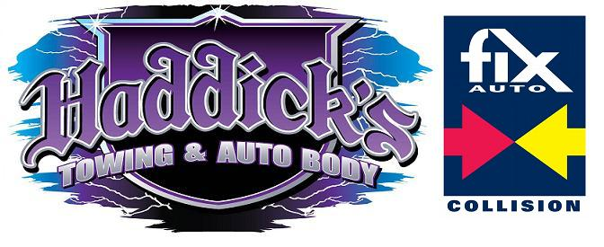
Limited Power of Attorney
I, ___________________________, do hereby authorize___________________________
And/or its agents, representatives, associates, or its affiliate’s_________________, to pick up my vehicle, (Year) __________ (Make) ________________ (Model) __________________
(License Plate)______________ (Vehicle ID Number VIN)_______________________________
That was towed on ___/___/______. I hereby authorize my agents to sign any and all documents and release on my behalf, and to sign all paper work and documents necessary to have my vehicle released. A faxed/photocopy of this authorization shall be considered as valid as the original. All my personal property within/or attached to the vehicle is the responsibility of my agent once removed from Haddick’s Towing, Inc.
I hereby release Haddick’s Towing, Inc. of all responsibility and liability pertaining of the described vehicle.
Executed on __________in (City) ______________________________, (State) _________

______________________________ _______________________________________
Signature of Registered Owner Printed name

(Photo copy of registered owners identification here)

